**Concurrent Collections**

**Need of Concurrent Collections: We have fallowing three reasons for the need of Concurrent Collections.**

1. As in the traditional collection most of the objects (except Vector and Hashtable) are **not thread safe because on these collection objects, multiple threads can operate simultaneously and there may be a chance of data inconsistency**
2. In traditional collection objects, **we have already existing thread safe collection** (Vector, Hashtable, synchronizedList (), synchronizedSet (), synchronizedMap () but these thread safe collection objects can be accessed by only one thread at a time .Hence **these thread safe collection objects performance wise not up to the mark**.

For every operation, even for read operation also only one thread can operate at a time and remaining thread has to wait until the first thread completes its work. In other word the total collection object was locked by one thread until it complete its work and the remaining thread has to wait. Hence it increases the waiting time of threads.

1. The last and most important problem with traditional collection is **while one thread iterating collection object** (i.e. one thread trying to get object one by one from the collection by iterating the collection objects) **and by mistake if other thread trying to modify the same collection object then immediately iterator fails by rising ConcurrentModificationExceptions**. In other word if one thread iterating the collection object then the other thread is not allowed to modify the collection object simultaneously and if we try to modify then we will get ConcurrentModificationExceptions.
2. Hence these traditional collection objects are **not suitable for scalable multi threaded applications**.
3. To overcome these problems SUN people **introduces concurrent collection in Java 1.6 Version**

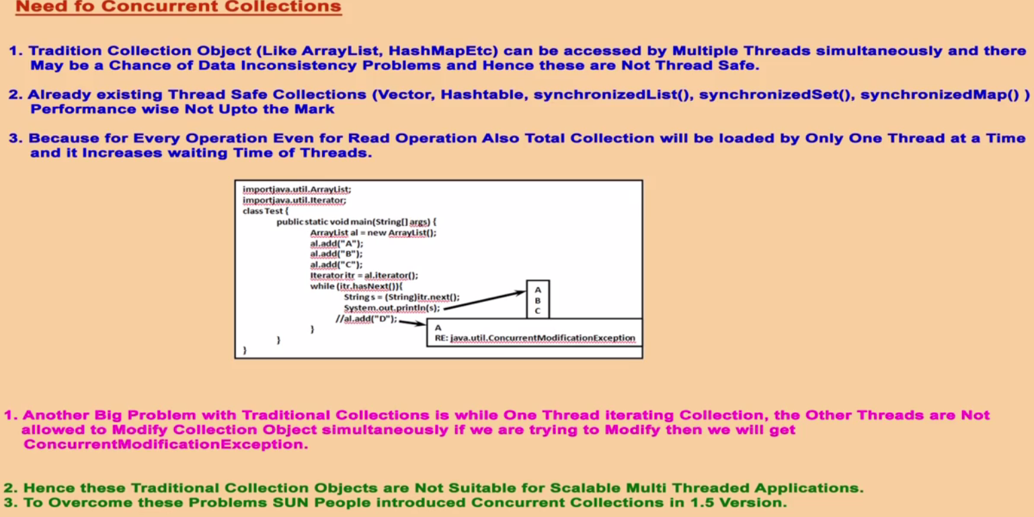

Example Showing ConcurrentModificationExceptions.

|  |  |
| --- | --- |
| **package com.concurrent.exception;**  **import java.util.ArrayList;**  **import java.util.Iterator;**  **public class MyThread extends Thread{**  **static ArrayList *al* = new ArrayList();**  **public void run(){**  **try {**  **Thread.*sleep*(2000);**  **} catch (InterruptedException e) {}**  **System.*out*.println("Child thread updating list");**  ***al*.add("D");**  **System.*out*.println(*al*);**  **}**  **public static void main(String[] args) {**  ***al*.add("A");**  ***al*.add("B");**  ***al*.add("C");**  **MyThread t = new MyThread();** // Creating child thread  **t.start (); //** Staring new thread which will execute run () for list updating**.**  **Iterator itr = *al*.iterator();**  **while(itr.hasNext()){**  **String s1= (String) itr.next();**  **System.*out*.println("Main Thread iterating list and current object is "+s1);**  }  System.*out*.println(*al*);  }  }  Output:  Main Thread iterating list and current object is A  Main Thread iterating list and current object is B  Main Thread iterating list and current object is C  [A, B, C]  Child thread updating list  [A, B, C, D] | Here in run () method we are trying to add one ArrayList object.  In the main () method main thread is trying to add three ArrayList object and after that main thread start child threads (MyThread) using t.start ().  Now after this we have two threads one is main thread and another is child thread.  Main thread trying to iterate element of list and simultaneously child thread trying to update the same list (adding one more object into al).  Hence immediately we will get **ConcurrentModificationExceptions**  If we run this program in java 1.5 or above version, we will not get any exceptions. |

**Note**: So here we did not get any exception because child thread got executed once main thread completed its execution and it happens because child thread went on sleep of 2 second and main thread got the changes to complete its execution and hence we did not get any ConcurrentModificationExceptions. Now when we comment the Thread.sleep (2000) then in this case while main thread iterating list elements then at the same time child thread trying to modify the same list which was locked by main thread and in this case we got ConcurrentModificationExceptions.

|  |  |
| --- | --- |
| **package** com.concurrent.exception;  **import** java.util.ArrayList;  **import** java.util.Iterator;  **public** **class** MyThread **extends** Thread{  **static** ArrayList<String> *al* = **new** ArrayList<String>();  **public** **void** run(){  **try** {  **// Thread.sleep(2000);**  } **catch** (Exception e) {  }  System.***out***.println("Child thread updating list");  ***al*.add("D");**  System.***out***.println(*al*);  }  **public** **static** **void** main(String[] args) {  *al*.add("A");  *al*.add("B");  *al*.add("C");  MyThread t = **new** MyThread(); // Creating child thread  t.start(); // Staring new thread which will execute run () for list updating.  Iterator<String> itr = *al*.iterator();  **while** (itr.hasNext()) {  **String s1 = (String) itr.next(); // Main thread trying to iterate**  System.***out***.println("Main Thread iterating list and current object is " + **s1**);  }  System.***out***.println(*al*);  }  } | Child thread updating list  Main Thread iterating list and current object is A  Exception in thread "main" [A, B, C, D]  **java.util.ConcurrentModificationException** at java.util.ArrayList$Itr.checkForComodification(ArrayList.java:909) at java.util.ArrayList$Itr.next(ArrayList.java:859) at com.concurrent.exception.MyThread.main(MyThread.java:25) String s1 = (String) itr.next();  So here child thread trying to update the same list which was getting iterated by main thread and hence we have got above exception. |

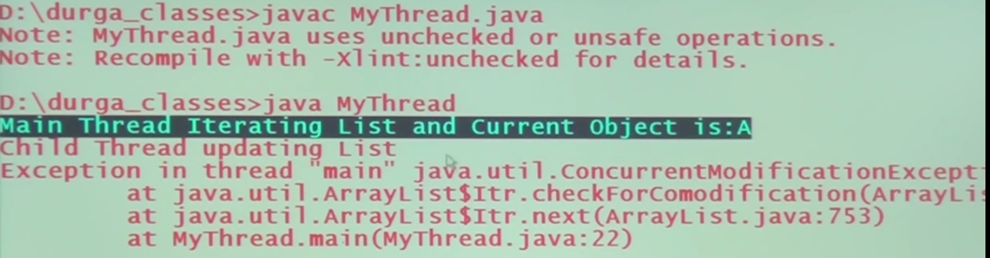

**Difference between Traditional & Concurrent Collection:**

|  |  |
| --- | --- |
| **Traditional Collection** | **Concurrent Collection** |
| 1. **Collection objects are not thread safe** | **Every objects are thread safe** |
| 1. **Performance is low** | **Performance is high** |
| 1. **While iterating one thread then remaining threads are not allowed to do any operation on the same object otherwise we will get ConcurrentModificationExceptions** | **While iterating one thread then remaining threads are allowed to do any operation on the same object in a safe manner and will never get ConcurrentModificationExceptions** |
| 1. **Not application for large multithreaded application** | **Applicable for large multithreaded application** |

There we have three concurrent collection classes:

1. ConurrentHashMap
2. CopyOnWriteArrayList
3. CopyOnWriteArraySet

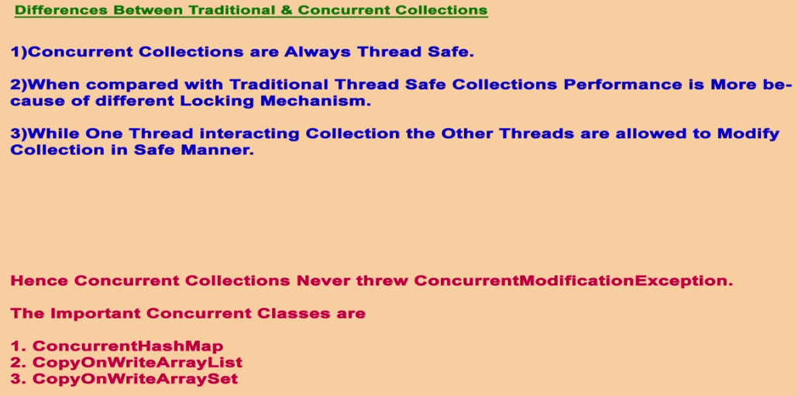

**ConcurrentMap(I):**

|  |  |  |
| --- | --- | --- |
| Map (I) 🡸  Methods:  **1-Object** put(Object key, Object value)  **2**- **void putAll(**Map m**)**  **3- Object get(**Object key**)**  **­4**- **Object remove(**Object key**)**  **5**- **boolean contains(**Object ke**y)**  **6**- **boolean contains(**Object value**)**  **7**- **boolean** isEmpty**()**  **8- int** size**()**  **9- Void** clear**()** | ConcurrentMap(I) 🡸  **Methods:**   1. putIfAbsent() 2. remove() 3. replace() | ConcurrentHashMap( class)  Methods: |

1. ConcurrentMap is a child interface of Map (I) interface
2. Since it is the child of Map, so all the methods of Map can be applied here also, apart from that it conatins their own three special methods

**Object putIfAbsent(Object key, Object value):** Add a new entry if the specified key is not alrady available in Map

|  |  |
| --- | --- |
| **Put()** | **putIfAbsent()** |
| In case of put map duplicate is not allowed and if we try to put duplicate key then the old value is replaced with current new value and returns old value | It is very similar to put() method of Map interface But In case of putIfAbsent() method first it will check whether the same key is already present or not, If the Key is alreay available then new entry won’t be added and and return old assocaited value and if the specified key in not available then only it add a new entry |
| **Object putIfAbsent(Object key, Object value){**  **If(!map.contains (key)){**  **map.put(key, value)**  **}else{**  **returns map.get(key);**  **}** | So as we can see that putIfAbsent() method internally uses Map interface only to add new value based on the checked condition |

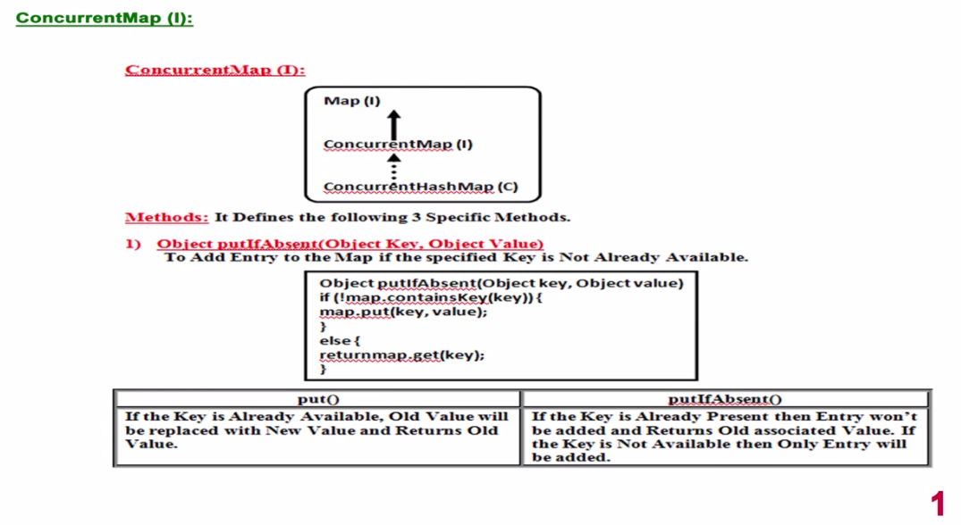

**Object remove(Object key, Object value):** Removes the entry if the Key and associated value is matched properly with the already available entry otherwise it does not remove the entry from the map

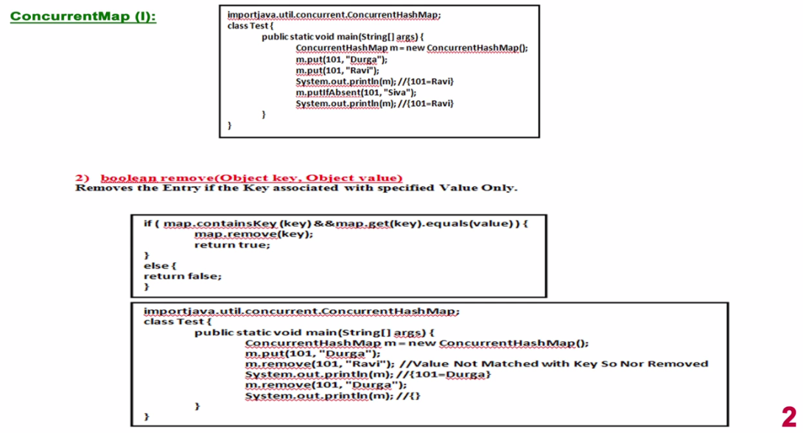

**Object replace(Object key, Object oldValue, Object newValue):**

**As the the method prototype it take three argutment for replacing the old value wih the new value of the same key. If the key and value matched with the existing entry then only oldValue gets replaced with newValue.**

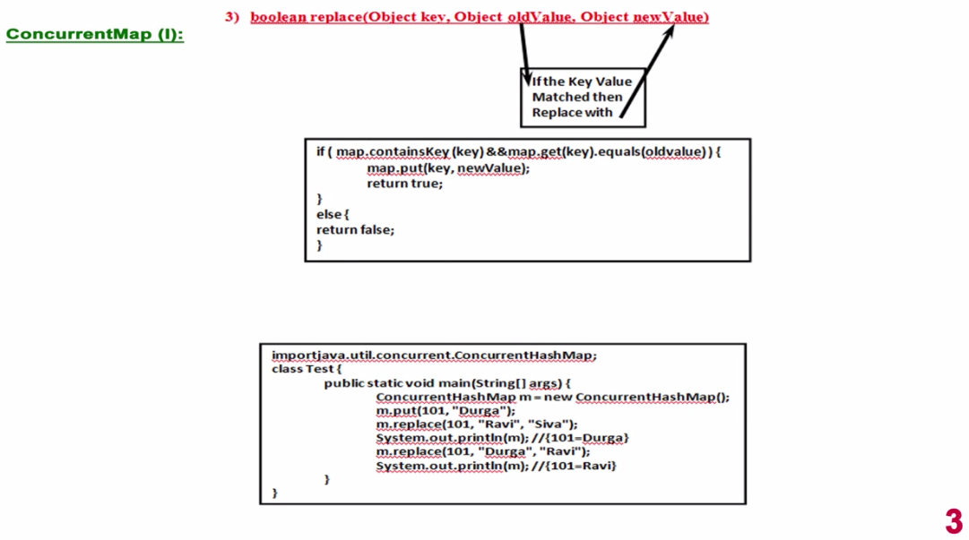

**Example of putIfAbsent, remove (), replace ()**

|  |
| --- |
| **package** com.concurrent.exception;  **import** java.util.concurrent.ConcurrentHashMap;  **public** **class** ConcurrentCollectionConcept {  **public** **static** **void** main(String[] args) {  ConcurrentHashMap<Integer, String> m = **new** ConcurrentHashMap<Integer, String>();  m.put(101, "Arun");  System.***out***.println("Original Entry-" + m);  m.put(101, "Ravi");  System.***out***.println("Put Dublicate Entry-" + m);  m.putIfAbsent(101, "Tarun");  System.***out***.println("m.putIfAbsent(101, Tarun);-" + m);  m.replace(101, "Kishan");  System.***out***.println("Map m.replace(101, Kishan)-" + m);  m.replace(101, "Kishan", "Bala");  System.***out***.println("ConcurrentMap m.replace(101, \"Kishan\", \"Bala\");" + m);  System.***out***.println("ConcurrentMap m.replace(101, \"Kishan\", \"Bala\");" + m.replace(101, "Kishan", "Bala"));  System.***out***.println("Final available entry-" + m);  System.***out***.println("ConcurrentMap remove-" + m.remove(101, "Kishan"));  System.***out***.println("Map remove-" + m.remove(101));  System.***out***.println("Now the remain entry in the map- " + m);  }  } |
| **Output:**  Original Entry-{101=Arun}  Put Dublicate Entry-{101=Ravi}  m.putIfAbsent(101, Tarun);-{101=Ravi}  Map m.replace(101, Kishan)-{101=Kishan}  ConcurrentMap m.replace(101, "Kishan", "Bala");{101=Bala}  ConcurrentMap m.replace(101, "Kishan", "Bala");false  Final available entry-{101=Bala}  ConcurrentMap remove-false  Map remove-Bala  Now the remain entry in the map- {} |

**ConcurrentHashMap Class:** It is the implementation class of ConcurrentMap. It is threading safe.

**Question**: As we know that in case HashMap multiple thread are allowed to operate on the same object and then in this case there is in-consistency in the output i.e. it is not thread safe. To resolve this or to ensure consistent output or for thread safety we can use Hashtable or **Collections.synchronizedMap (new HashMap)**.

But here at a time only one thread is allowed to operate on the object and the remaining thread has to wait until the current thread complete its execution. So in this case there is performance is not up-to the mark.

So finally we have got ConcurrentHashMap which is thread safe as well as its performance is also up-to the mark. **But the question is how the ConcurrentHashMap achieve both the things together?**

A: As we know that the initial default capacity of HashMap is 16 and it gets divided into 16(0 to 15) parts which is called buckets or segments. Let’s say we have multiple threads which want to perform some operation, In case of normal synchronizedMap () or Hashtable the whole object gets locked by one thread and other threads has to wait until the current executing thread complete its execution. But in case of CCHM instead of locking on whole map object the locking is applied on segment or bucket level.

Apart from that for read operation there is no any lock is required on the segment or bucket i.e. for read operation any number of threads can perform read operation on segment or bucket. But for update / write (add) operation lock is required. Let’s say we have 16 threads and one thread is performing update/ write operation on one of the 16 segment so simultaneously the remaining 15 threads also can perform the update/write operation on the remaining segment or buckets.

So instead of locking whole object, the lock is applied on segment or bucket level and read operation can be performed by any number of threads without any lock, only in update/write operation the segment or bucket level lock is required. Hence the performance gets increased in case CCHM.

**Concurrency Level:**

As we know that the HashMap / CCHM by default is divided into 16 segments or buckets and this 16 number is called **Concurrency Level,** so 16 concurrency level means the map is divided into 16 buckets. In most of the cases HashMap / CCHM divided into 16 buckets so most of the time number of segment and Concurrency is equal so by default for every bucket one thread concept we can use.

Now let’s the default capacity is 16 and so there would be 16 buckets but concurrency level is also 16 then by default for every bucket there is one lock (i.e. for 16 bucket = 16 Concurrency level = 16 locks) .

Now let’s assume initial capacity is 16 but concurrency level is 8 (i.e. 8 locks) then for every two buckets one lock will be maintain i.e. for every two buckets only one thread is allowed to update operate.

But sometimes the initial capacity is same 16 but the number of the concurrency level (let’s say 32) is more than buckets, then for every bucket two lock will be maintained and thus on each bucket two thread are allowed i.e. for first half of the bucket, first lock and for another half of the bucket, another lock.

So most of the time buckets and concurrency level is same and in that case bucket level lock will be applied but if the bucket and concurrency level is different, then locking mechanism will be adjust accordingly.

**Conclusion:**

1. It is based on Hashtable data structure
2. It allows concurrent (simultaneously) read and thread safe update operation
3. To perform read operation thread won’t require any lock. But to perform update operation thread requires lock, but this lock will be on a particular bucket or segment instead of total map object.
4. Concurrent update is achieved by internally dividing a map into smaller portion, which is defined by concurrency level.
5. The default concurrency level is 16
6. It allows any number of read operations but 16 update operations at a time by default
7. Null is not allowed for Key and Value both
8. While one thread is iterating, the another thread can perform update operation and CCHM never throw ConcurrentModificationExceptions

**Constructors:**

1. ConcurrentHashMap m = new ConcurrentHashMap(); // Empty Map with Initial capacity – 16
2. ConcurrentHashMap m = new ConcurrentHashMap(int initialCapacity);
3. ConcurrentHashMap m = new ConcurrentHashMap(int initialCapacity, float fillRatio);
4. **ConcurrentHashMap m = new ConcurrentHashMap(int initialCapacity, float fillRatio, int ConcurrencyLevel);**
5. ConcurrentHashMap m = new ConcurrentHashMap(Map m);

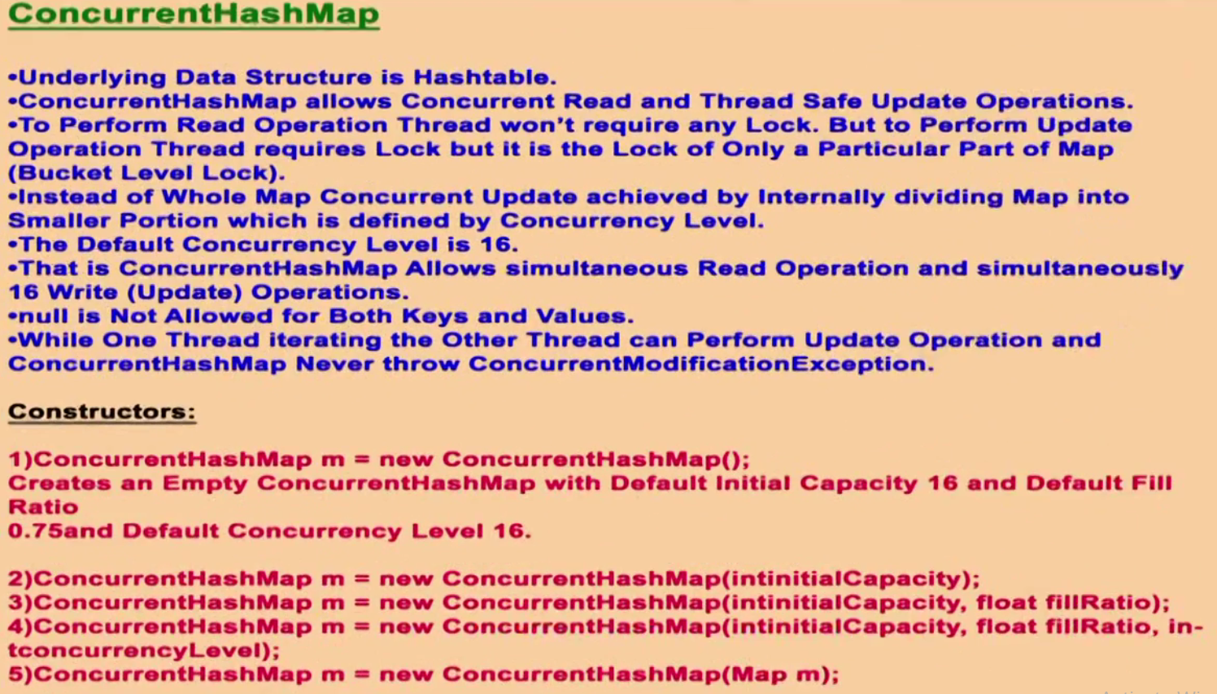

|  |
| --- |
| **package** com.concurrent.exception;  **import** java.util.concurrent.*;  **public** **class** ConcurrentHashMaptTest {  **public** **static** **void** main(String[] args) {  ConcurrentHashMap<Integer, String> m = **new** ConcurrentHashMap<Integer, String>();  m.put(101, "A");// {101, A}  m.put(102, "B");// {102, B}  m.putIfAbsent(103, "C");// {103, C}  m.putIfAbsent(101, "D");// No entry  m.remove(101, "D"); // No removal  m.replace(102, "B", "E");// {102, E}  System.***out***.println(m);  // output: {101=A, 102=E, 103=C}  }  } |

|  |
| --- |
| **package com.concurrent.exception;**  **import java.util.ArrayList;**  **import java.util.HashMap;**  **import java.util.Iterator;**  **import java.util.Set;**  **import java.util.concurrent.ConcurrentHashMap;**  **public class MyThread extends Thread {**  **static HashMap<Integer, String> al = new HashMap<Integer, String>();**  **// static ConcurrentHashMap<Integer, String> al = new ConcurrentHashMap<Integer, String>();**  **public void run() {**  **try {**  **Thread.sleep(2000);**  **} catch (Exception e) {**  **}**  **System.out.println("Child thread updating list");**  **al.put(103, "C");**  **System.out.println(al);**  **}**  **public static void main(String[] args) throws InterruptedException {**  **al.put(101, "A");**  **al.put(102, "B");**  **// Main thread is adding two data {101=A, 102=B}**  **MyThread t = new MyThread(); // Main thread Creating child thread**  **t.start (); // main thread starts child thread which will execute run () for list updating.**    **Set<Integer> keySet = al.keySet(); // Getting KeySet of the above added entries**  **Iterator<Integer> itr = keySet.iterator();// Creating iterator using KeySet**  **// Now main thread iterating and simultaneously**  **// child thread trying to update same map object**  **while (itr.hasNext()) {**  **Integer s1 = (Integer) itr.next();**  **System.out.println("Main Thread iterating list and current entry is- " + s1 + "-" + al.get(s1));**  **Thread.sleep(3000);**  **}**  **System.out.println(al);**  **}**  **}** |
| **Output : while using HashMap:**  Main Thread iterating list and current entry is- 101-A  Child thread updating list  {101=A, 102=B, 103=C}  Exception in thread "main" java.util.ConcurrentModificationException  at java.util.HashMap$HashIterator.nextNode(HashMap.java:1445)  at java.util.HashMap$KeyIterator.next(HashMap.java:1469)  at com.concurrent.exception.MyThread.main(MyThread.java:41)  **So we have go ConcurrentModificationException because Norml HashMap does not allow iterating and updating the same object simultaneously. Now let’ check with ConcurrentHashMap. Uncomment CCHM** |
| Main Thread iterating list and current entry is- 101-A  Child thread updating list  {101=A, 102=B, 103=C}  Main Thread iterating list and current entry is- 102-B  Main Thread iterating list and current entry is- 103-C  {101=A, 102=B, 103=C} |

So in case of CHM we did not get any exception

Note: While main thread iterating at the same time other thread is allowed to any modification to the map object, but the updating will be available to the iterator or not, there is no guarantee.

|  |  |
| --- | --- |
| **public void run() {**  **try {**  **Thread.sleep(5000);**  **} catch (Exception e) {**  **}**  **System.out.println("Child thread updating list");**  **al.put(103, "C");**  **System.out.println(al);**  **}** | Main Thread iterating list and current entry is- 101-A  Main Thread iterating list and current entry is- 102-B  {101=A, 102=B}  Child thread updating list  {101=A, 102=B, 103=C, 108=M, 1023=K} |

So here when we increase sleep time for child thread then main thread finished its iteration first and completes its execution and went into dead state and after that child thread updated the map hence Main thread could not get the chance to iterate the added entry by child thread because Main thread is using Iterator which is forward direction iterator and hence once skip the backward entries, could not iterate by going back

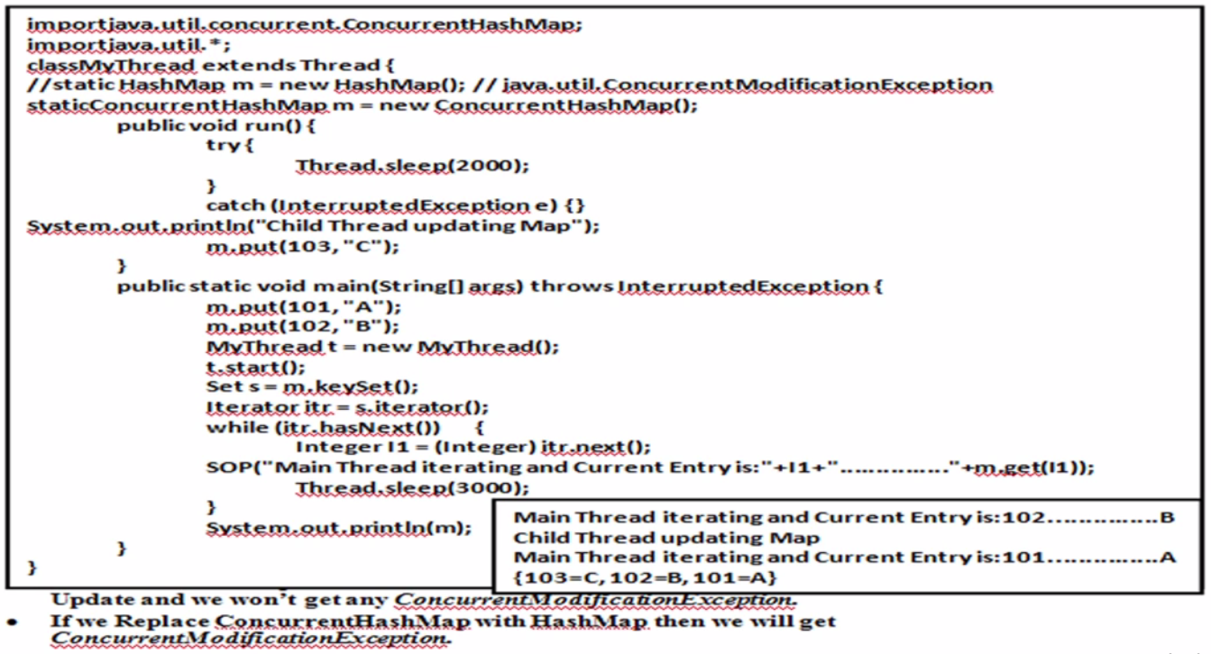

**Difference between HashMap and ConcurrentHashMap**

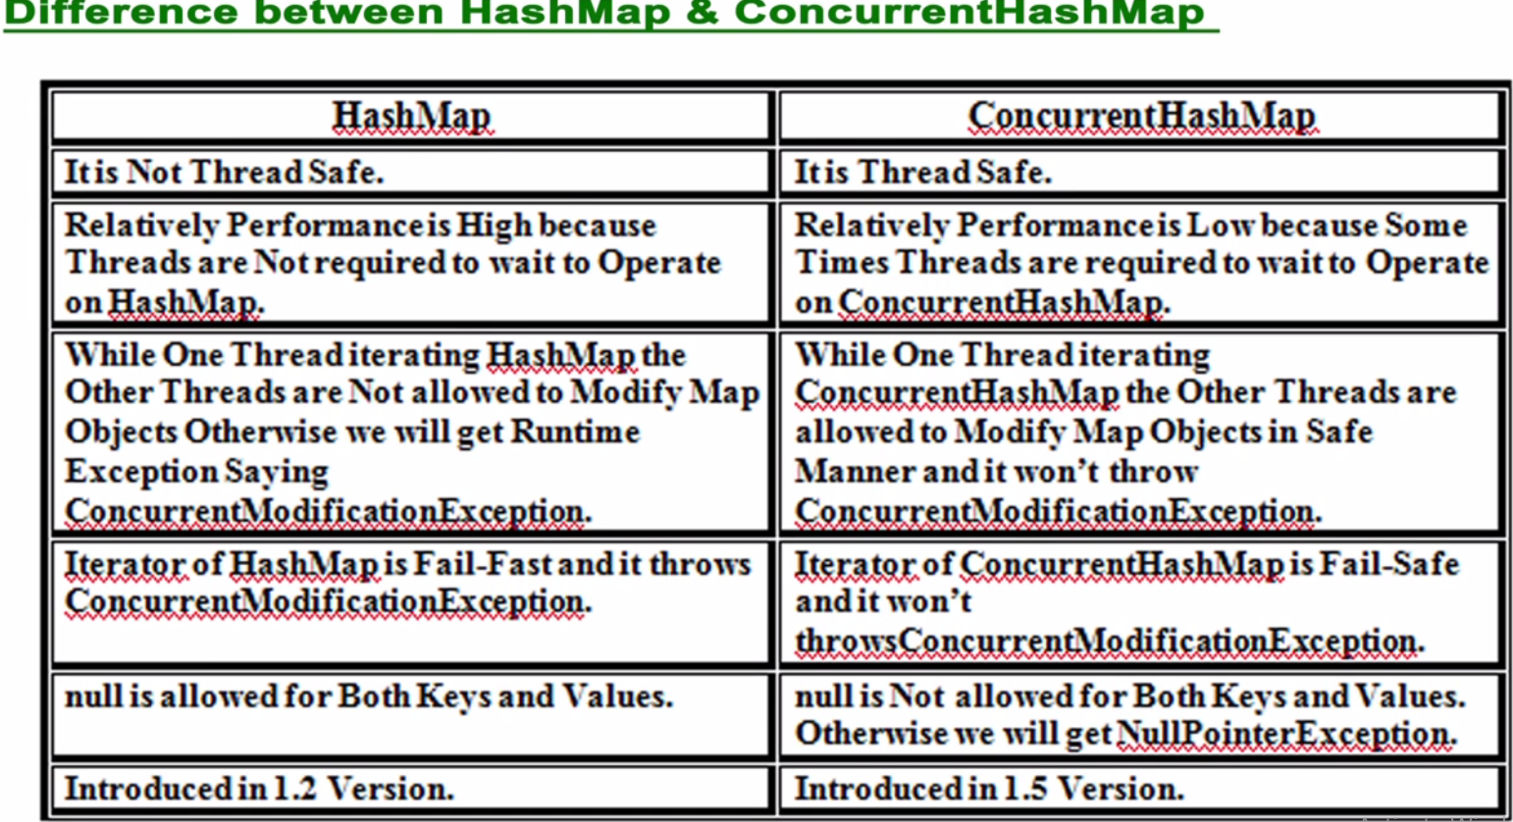

|  |  |
| --- | --- |
| HashMap | ConcurrentHashMap |
| It is not thread safe | Thread safe |
| Here if one thread is Iterating and simultaneously another thread trying to update the same object then immediately Iterator will fail fast and throw ConcurrentModificationException | Iterator is fail-safe |

**Difference between SynchronizedMap, Hashtable and ConcurrentHashMap**

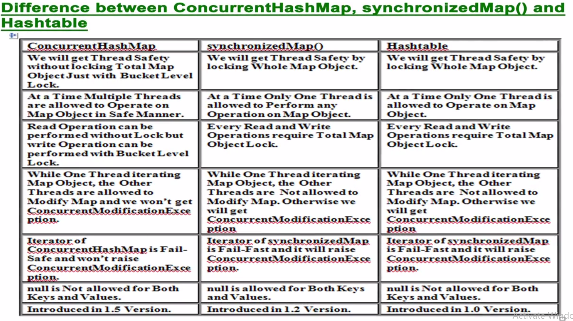

**CopyOnWriteArrayList (class)**

|  |  |  |
| --- | --- | --- |
| **Collection(I) 🡸** | **List(I) 🡸** | **CopyOnWriteArrayList(c)** |

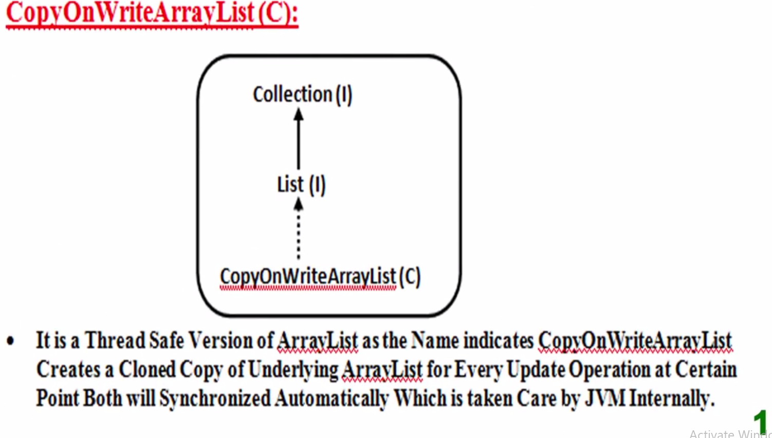 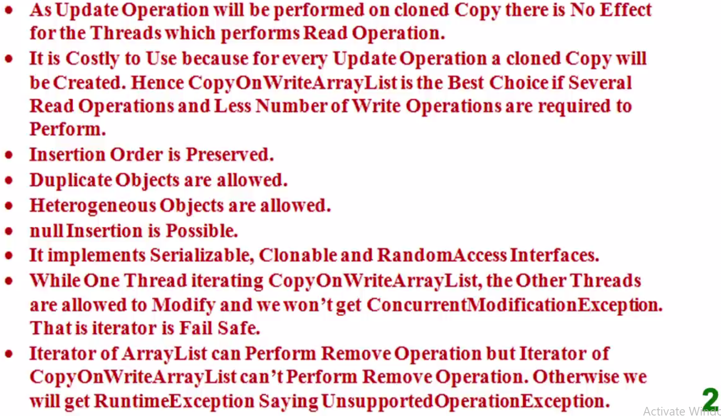

Q: Why the name is **CopyOnWriteArrayList** and how we are getting Thread safety?

A: Let’s say we have an ArrayList object [Cow al]. Let’s say in multithreaded environment few thread wants to perform some write / update operation then for every update / write operation a separate cloned copy of same existing ArrayList object will be created by JVM and once write / update operation completes successfully then at a certain point this updated cloned copy will be synchronized with original ArrayList by the JVM automatically, that is why it is called CopyOnWriteArrayList.

A separate cloned copy of the object is created for every write / update operation only, but for read operation there is no need to create any separate copy. Hence the read and write / update operation can be performed simultaneously without and ConcurrentModificationException and hence it is Thread safe also. While in case of normal ArrayList we will get ConcurrentModificationException if we perform read and update operation simultaneously, because in Normal ArrayList there is no separate cloned copy is created for update/write operation.

Iterator of Normal ArrayList is fail-fast while Iterator of CopyOnWriteArrayList is fail-safe.

In case of Normal ArrayList we can remove any element using remove () method but in case of **CopyOnWriteArrayList** remove operation does not support because for every update a separate clone copy is created and if we perform remove operation on original or cloned copy then at the time of synchronization both the copy a conflict or problem can be created that is why remove () operation does not support in **CopyOnWriteArrayList**

**Constructors & Methods of CopyOnWriteArrayList**

|  |  |
| --- | --- |
|  | **Since CopyOnWriteArrayList** is the implementation class of List (I) and List (I) is the direct child of Collection (I) so whatever method is available in Collection and List interface, by default will be available for **CopyOnWriteArrayList** class**.**  **But along with the existing one more method is available in CopyOnWriteArrayList**   1. **boolean addIfAbsent(Object o)** 2. **int addAllAbsent(Collection c)** |

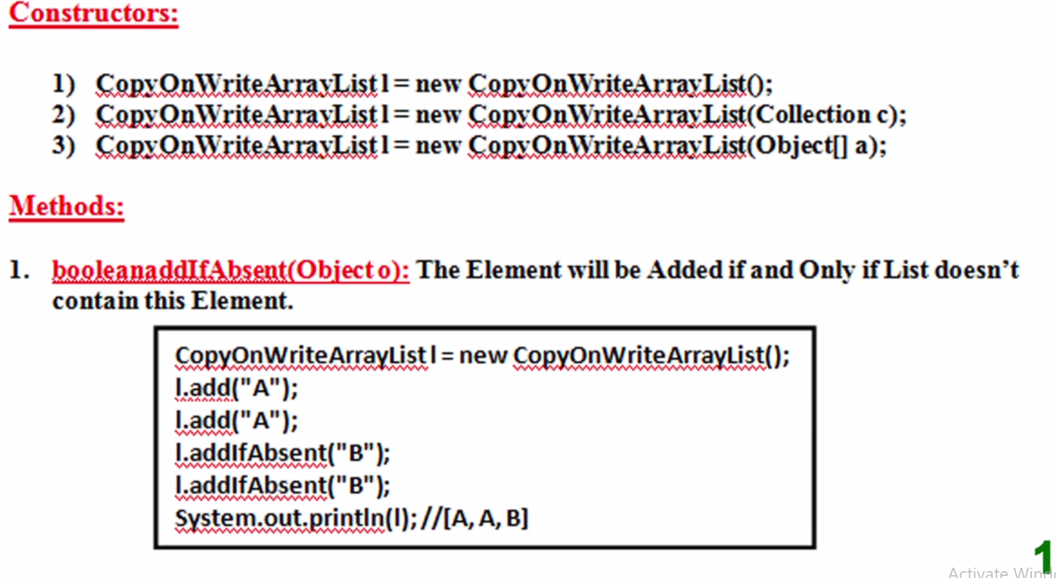

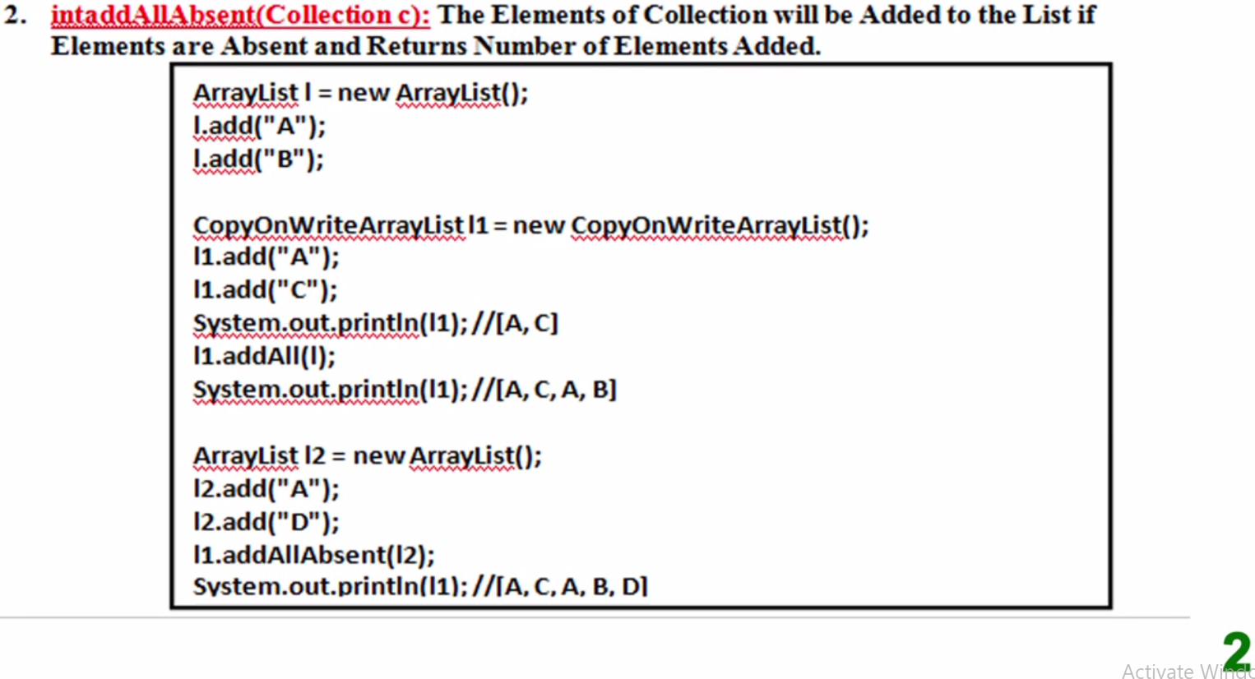

Here in the above program element ‘A’ is being added three times (l , l1, l2) and again by using CopyOnWriteArrayList object we again trying to add (l2) object using addAllAbsent(l2) method. So now in this case it will first check that if l1 has already contains [A,D] or not. So as per the program l1 contains already contains [A,C,A,B] and again we are trying to add [A,D] so now only ‘D’ will be added because ‘A’ element is already available in (l1) object.

|  |  |
| --- | --- |
| **package** com.concurrent.exception;  **import** java.util.ArrayList;  **import** java.util.concurrent.CopyOnWriteArrayList;  **public** **class** CopyOnWriteArrayListConcept {  **public** **static** **void** main(String[] args) {  ArrayList al = **new** ArrayList();  al.add(1);  al.add(1);    CopyOnWriteArrayList cwal = **new** CopyOnWriteArrayList();  cwal.add(1);// [1]  cwal.add(1);// [1,1]  System.***out***.println(cwal.addIfAbsent(2));  // added 2 and return true  System.***out***.println(cwal.addIfAbsent(2));  // will not add 2 and return false  cwal.addAllAbsent(al);  System.***out***.println(cwal);  }  }  Output:  true  false  [1, 1, 2] | **package** com.concurrent.exception;  **import** java.util.ArrayList;  **import** java.util.concurrent.CopyOnWriteArrayList;  **public** **class** CopyOnWriteArrayListConcept {  **public** **static** **void** main(String[] args) {  ArrayList al = **new** ArrayList();  al.add("A");  al.add("B");  System.***out***.println("al contains-" + al);  CopyOnWriteArrayList cwal = **new** CopyOnWriteArrayList();  cwal.addIfAbsent("A");  cwal.addIfAbsent("C");  System.***out***.println("cwal contains-" + cwal);  cwal.addAllAbsent(al);  System.***out***.println("After adding al into addAllAbsent()-" + cwal);  }  }  Output:  al contains-[A, B]  cwal contains-[A, C]  After adding al into addAllAbsent()-[A, C, B] |

Example of Iterating and adding list simultaneously

|  |  |
| --- | --- |
| **package** com.concurrent.exception;  **import** java.util.Iterator;  **import** java.util.concurrent.*;  **public** **class** MyCopyOnWriteArrayListThread **extends** Thread {  **static** CopyOnWriteArrayList<String> *al* = **new** CopyOnWriteArrayList<String>();  // **static** ArrayList<String> *al* = **new** ArrayList<String>();  **public** **static** **void** main(String[] args) **throws** InterruptedException {  *al*.add("A");  *al*.add("B");  *al*.add("K");  *al*.add("M");  MyCopyOnWriteArrayListThread t = **new** MyCopyOnWriteArrayListThread();  t.start();  Iterator<String> itr = *al*.iterator();  **while** (itr.hasNext()) {  String s1 = itr.next();  System.***out***.println("Main Thread iterating--" + s1);  Thread.*sleep*(3000);  }  System.***out***.println(*al*);  }  **public** **void** run() {  **try** {  Thread.*sleep*(2000);  } **catch** (Exception e) {  }  System.***out***.println("Child thread updating list");  *al*.add("C");  System.***out***.println(*al*);  }  } | 1. Created one static **CopyOnWriteArrayList** object so that a single could be available to whole class. 2. In the main method added four elements 3. Inside main class main tread creates child thread and start the same child thread 4. Now main thread iterating the list and at the same time the child thread trying to add new list in the same object   Since here we are using **CopyOnWriteArrayList** object that is why we are not getting any ConcurrentModificationException.  Note: if we uncomment  **static** ArrayList<String> *al* = **new** ArrayList<String>();  and if now try to iterate and update the same list object simultaneously then we will get below exception  Main Thread iterating--A  Child thread updating list  [A, B, K, M, C]  Exception in thread "main" java.util.**ConcurrentModificationException** com.concurrent.exception.MyCopyOnWriteArrayListThread.main  (MyCopyOnWriteArrayListThread.java:34) |

Output: with CopyOnWriteArrayList:

|  |  |
| --- | --- |
| Main Thread iterating--A  Child thread updating list  [A, B, K, M, C]  Main Thread iterating--B  Main Thread iterating--K  Main Thread iterating--M  [A, B, K, M, C] | **Note**: We have not got any exception but as per the output the element added by child thread could not get the chance to be iterated by main thread. Reason is while main thread iterating at the same time child thread would have added new element in the list and got skipped and iterator moves forward for iterating and since Iterator moves only in forward direction that is why main thread iterator could not get the chance to iterate even though it have got added In the same list object |

**Example to show that Iterator remove () does not support by CopyOnWriteArrayList:**

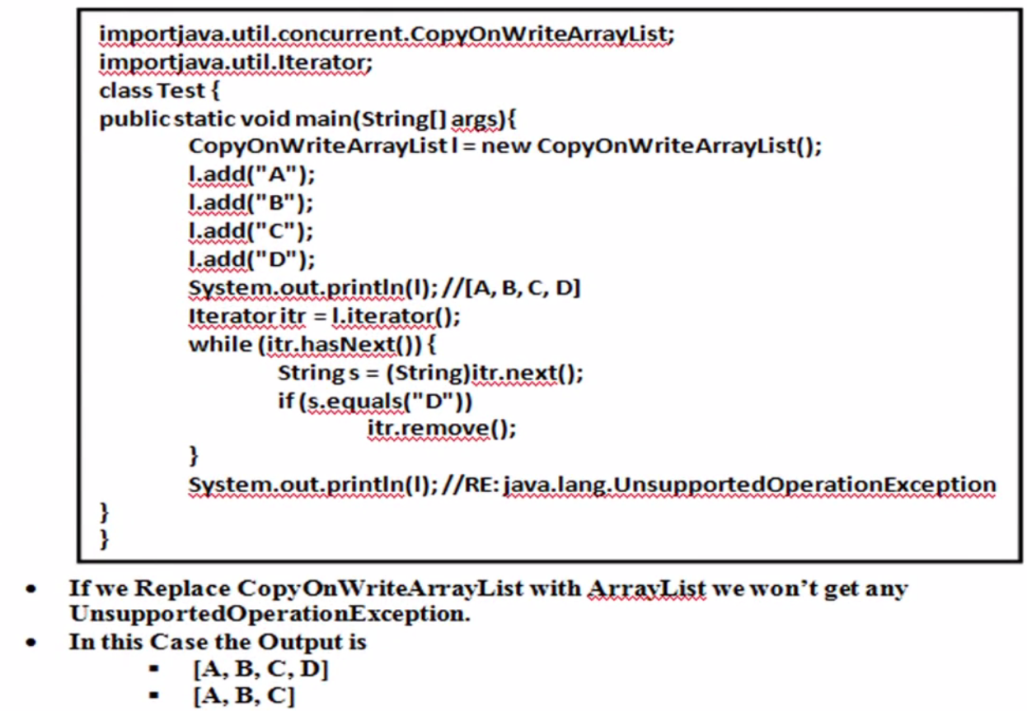

|  |  |
| --- | --- |
| **package com.concurrent.exception;**  **import java.util.ArrayList;**  **import java.util.Iterator;**  **import java.util.concurrent.CopyOnWriteArrayList;**  **public class CopyOnWriteArrayListConcept {**  **public static void main(String[] args) {**  **ArrayList al = new ArrayList();**  **al.add("A");**  **al.add("B");**  **System.*out*.println("al contains-" + al);**  **CopyOnWriteArrayList cwal = new CopyOnWriteArrayList();**  **cwal.addIfAbsent("A");**  **cwal.addIfAbsent("C");**  **System.*out*.println("cwal contains-" + cwal);**  **cwal.addAllAbsent(al);**  **System.*out*.println("After adding al into addAllAbsent()-" + cwal);**  **Iterator itr = cwal.iterator();**  **while (itr.hasNext()) {**  **String s1 = (String) itr.next();**  **System.*out*.println(s1);**  **//if (s1.equals("A"))**  **//itr.remove();**  **}**  **}**  **}** | Output: al contains-[A, B]  cwal contains-[A, C]  After adding al into addAllAbsent()-[A, C, B]  A  C  B  Now if we try to remove element during iteration then we will get exception.  Exception in thread "main" java.lang.UnsupportedOperationException  main(CopyOnWriteArrayListConcept.java:27) |

So **CopyOnWriteArrayList Iterator can perform only read operation** and if we try to perform remove operation on CopyOnWriteArrayList Iterator then we will get run time exception “UnsupportedOperationException.

In case of Normal List Iterator we can perform remove operation bur in case of CopyOnWriteArrayList Iterator remove operation is supported.

**Example to perform Iteration and update list object simultaneously:**

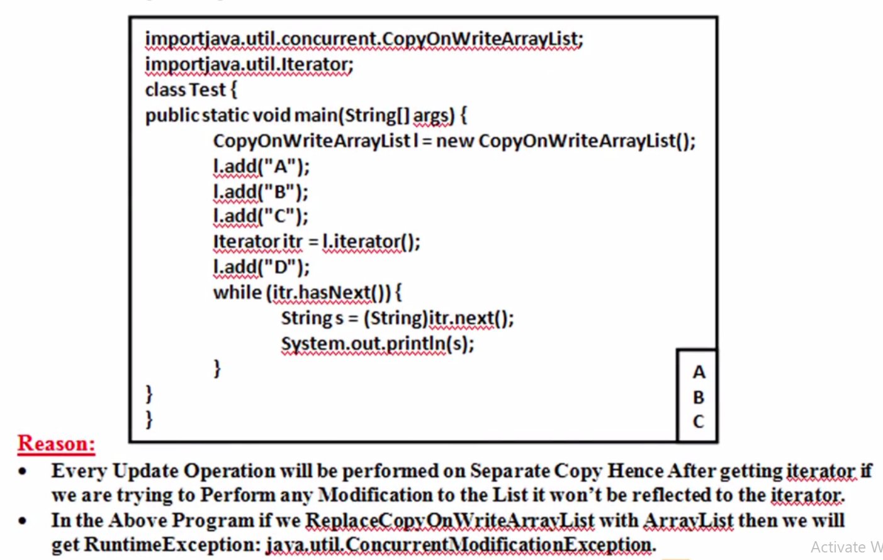

|  |  |
| --- | --- |
| **package** com.concurrent.exception;  **import** java.util.ArrayList;  **import** java.util.Iterator;  **import** java.util.concurrent.CopyOnWriteArrayList;  **public** **class** CopyOnWriteArrayListConcept {  **public** **static** **void** main(String[] args) {  ArrayList al = **new** ArrayList();  al.add("A");  al.add("B");  System.***out***.println("al contains-" + al);  CopyOnWriteArrayList cwal = **new** CopyOnWriteArrayList();  cwal.addIfAbsent("A");  cwal.addIfAbsent("C");  System.***out***.println("cwal contains-" + cwal);  cwal.addAllAbsent(al);  System.***out***.println("After adding al into addAllAbsent()-" + cwal);  Iterator itr = cwal.iterator();  cwal.add("D");  System.***out***.println("After start iteration adding al -" + cwal);  **while** (itr.hasNext()) {  String s1 = (String) itr.next();  System.***out***.println("CWAL Iteration-" + s1);  }  }  } | **Here in this example we have added the element getting iteration and we did not get any exception but the element added after iteration would not be reflected in iteration. In the below output element “D” is added after iteration and does not reflect in the iteration.**  **Output:**  al contains-[A, B]  cwal contains-[A, C]  After adding al into addAllAbsent()-[A, C, B]  After start iteration adding al -[A, C, B, D]  CWAL Iteration-A  CWAL Iteration-C  CWAL Iteration-B |

**Reason: As we know that for every update operation a separate cloned copy is created and then update operation is performed and in the later after sometime both the copy will be sync with each other by JVM.**

**Here Iterator is performing read operation on the original object but the update operation is being performed on cloned copy and that is why in the read operation is performed by Iterator does not include “D” element in the iteration but after sometime when both the copy gets synchronized with each other then “D” will be shown in the same list object.**

**Note: If instead of CopyOnWriteArrayList** **if we are doing the same with Normal ArrayList object then we will get ConcurrentModificationException**

**Difference between ArrayList and CopyOnWriteArrayList**

|  |  |
| --- | --- |
| **ArrayList(AL)** | **CopyOnWriteArrayList(CWAL)** |
| 1. **It is not thread safe** | **It is Thread safe because every update operation will be performed on separate cloned copy** |
| 1. **While one thread is iterating List object , the other threads are not allowed to modify the list otherwise we will get ConcurrentModificationException** | **While one thread is iterating List object , the other threads are allowed to modify the list in safe manner and we will get ConcurrentModificationException** |
| 1. **ArrayList Iterator is fail-fast** | **CopyOnWriteArrayList Iterator is fail-safe** |
| 1. **Iterator of ArrayList can perform remove operation** | **Iterator of CopyOnWriteArrayList cannot perform remove operation, otherwise we will get runtime Unsupported Operation Exception** |
| 1. **Introduced in 1.2 V** | **In 1.5 V** |

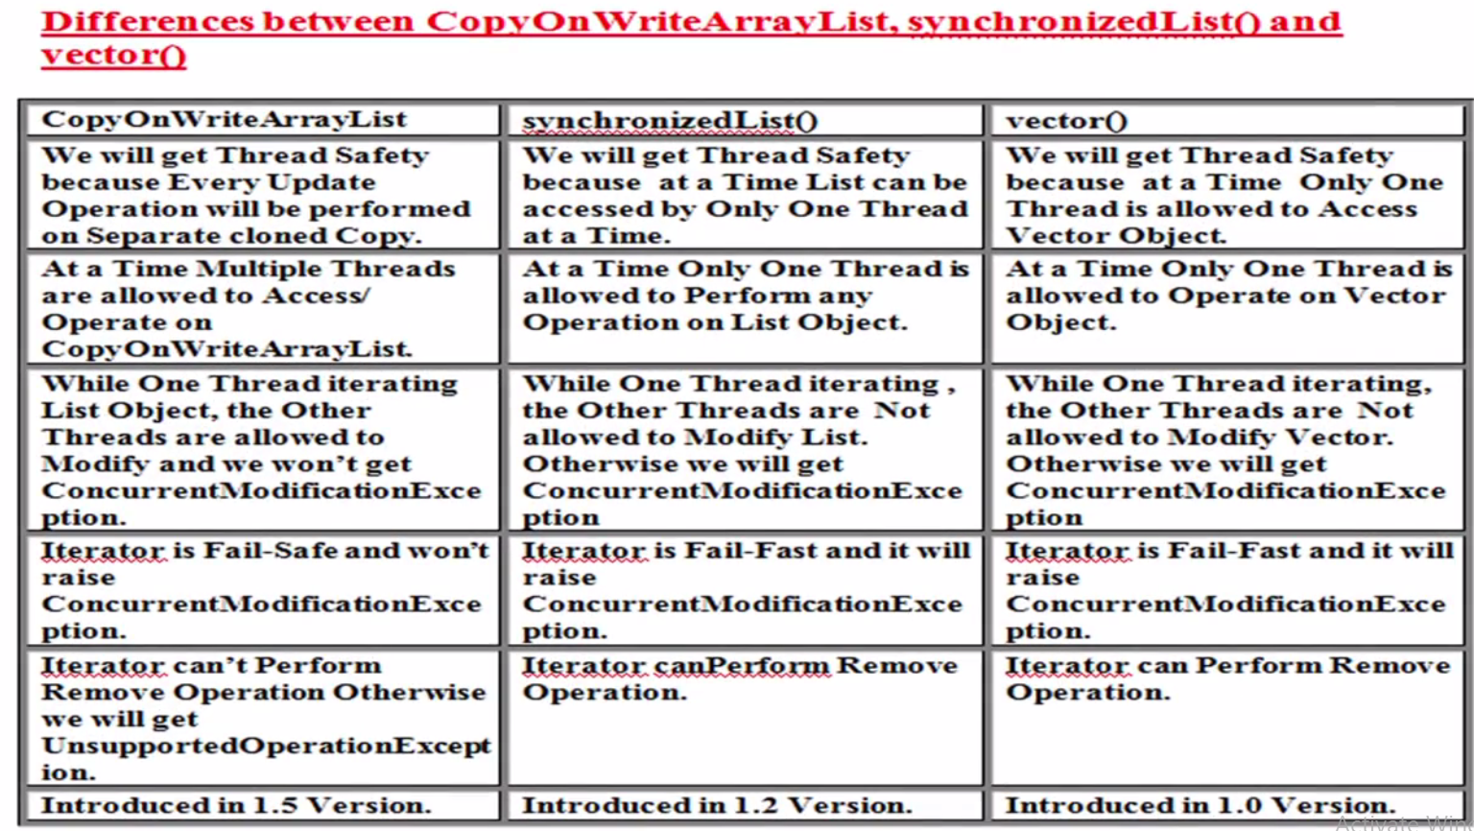

**CopyOnWriteArraySet**

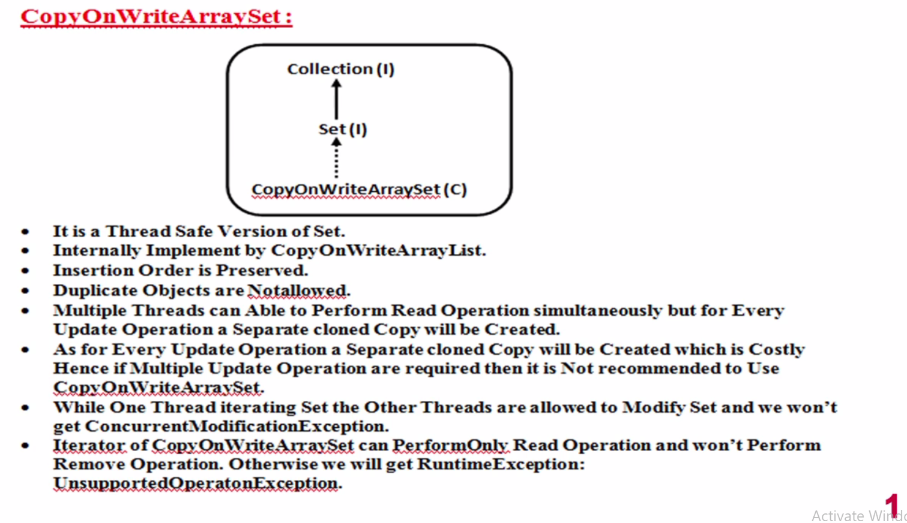

**Note1-: since internally it is implemented by CopyOnWriteArrayList that is why Insertion order is preserved.**

**Note2-: Since it implements Set (I) also that is why duplicates objects are not allowed.**

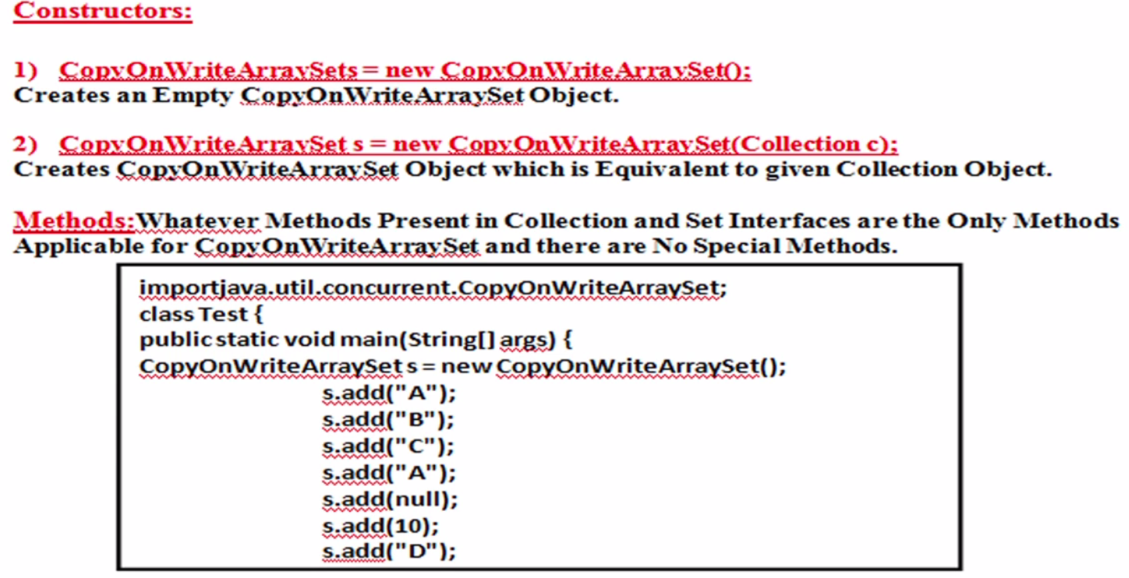 **So it exactly as same as CopyOnWriteArrayList with a small difference that duplicates are not allowed and that is why whatever the new methods were added in CopyOnWriteArrayList like [addIfAbsent() & addAllAbsent()] is also notavailable in CopyOnWriteArraySet because these two methods does the same thing which is basic nature of Set i.e. duplicate element will not be added and if try to add then it just simply returns false and does not throw any exception.**

